Nama : Tsaniya Faridah Maulida (211331031)
Partner : Erika Dwi Jayanti (211331006)
Kelas : 1A - TTE
Tanggal Praktikum : Sabtu, 23 April 2022

JURNAL PRAKTIKUM ELEKTRONIKA DIGITAL
ENCODER 8 TO 3 (AKTIF LOW)

  - Tabel Kebenaran
Tabel 1. Tabel Kebenaran Aktif Low
Input |  |  |  |  |  |  |  | Output
I₀ | I₁ | I₂ | I₃ | I₄ | I₅ | I₆ | I₇ | A2 | A1 | A0
0 | 1 | 1 | 1 | 1 | 1 | 1 | 1 | 0 | 0 | 0
1 | 0 | 1 | 1 | 1 | 1 | 1 | 1 | 0 | 0 | 1
1 | 1 | 0 | 1 | 1 | 1 | 1 | 1 | 0 | 1 | 0
1 | 1 | 1 | 0 | 1 | 1 | 1 | 1 | 0 | 1 | 1
1 | 1 | 1 | 1 | 0 | 1 | 1 | 1 | 1 | 0 | 0
1 | 1 | 1 | 1 | 1 | 0 | 1 | 1 | 1 | 0 | 1
1 | 1 | 1 | 1 | 1 | 1 | 0 | 1 | 1 | 1 | 0
1 | 1 | 1 | 1 | 1 | 1 | 1 | 0 | 1 | 1 | 1

  - Gambar Rangkaian
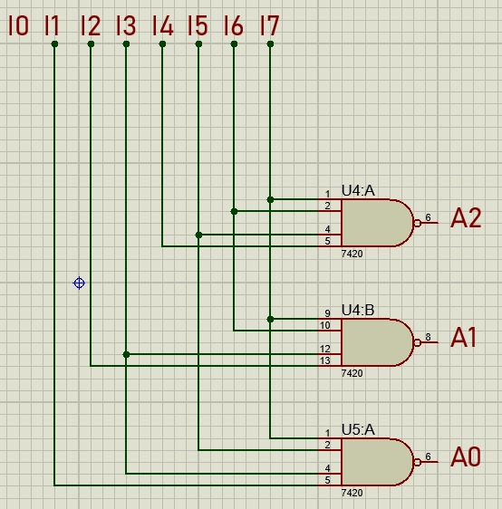
Gambar 1 Rangkaian Encoder 8 to 3 Aktif Low

  - Hasil Praktikum
Tabel 2. Hasil Praktikum Encoder 8 to 3 Aktif Low
Input |  |  |  |  |  |  |  | Output |  |  | Gambar Simulasi
I₀ | I₁ | I₂ | I₃ | I₄ | I₅ | I₆ | I₇ | A₂ | A₁ | A₀ | Gambar Simulasi
0 | 1 | 1 | 1 | 1 | 1 | 1 | 1 | 0 | 0 | 0 | 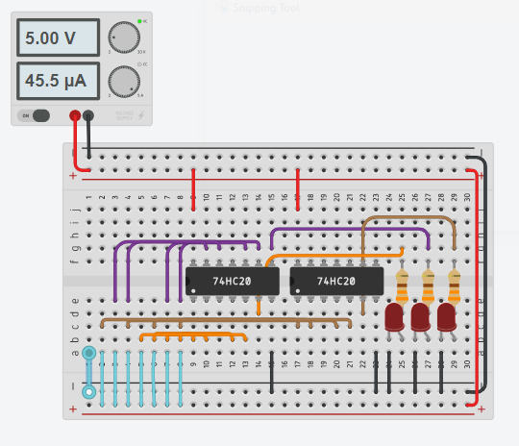
1 | 0 | 1 | 1 | 1 | 1 | 1 | 1 | 0 | 0 | 1 | 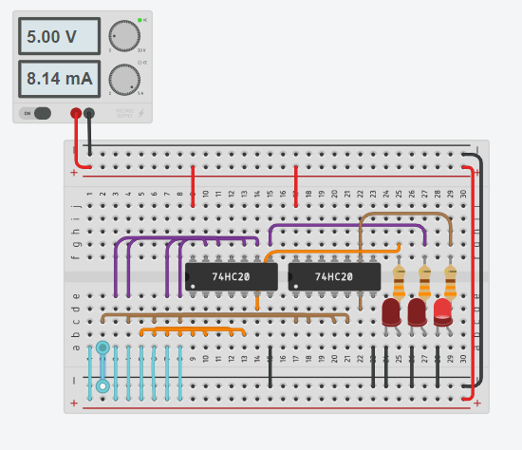
1 | 1 | 0 | 1 | 1 | 1 | 1 | 1 | 0 | 1 | 0 | 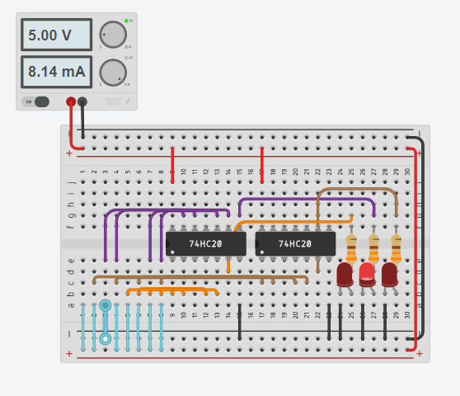
1 | 1 | 1 | 0 | 1 | 1 | 1 | 1 | 0 | 1 | 1 | 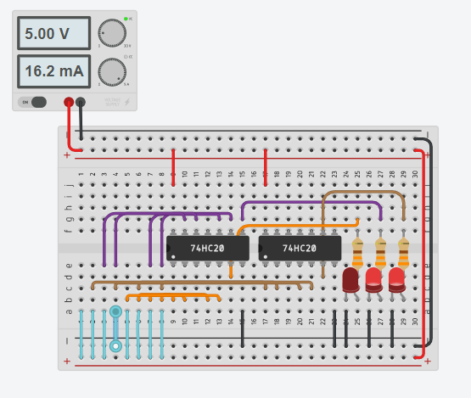
1 | 1 | 1 | 1 | 0 | 1 | 1 | 1 | 1 | 0 | 0 | 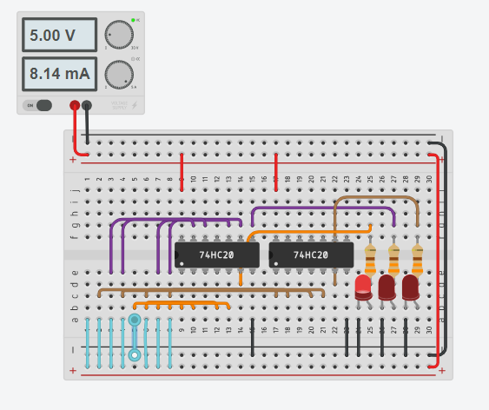
1 | 1 | 1 | 1 | 1 | 0 | 1 | 1 | 1 | 0 | 1 | 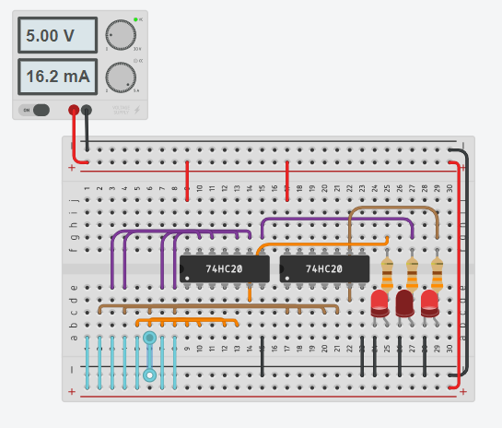
1 | 1 | 1 | 1 | 1 | 0 | 1 | 0 | 1 | 1 | 0 | 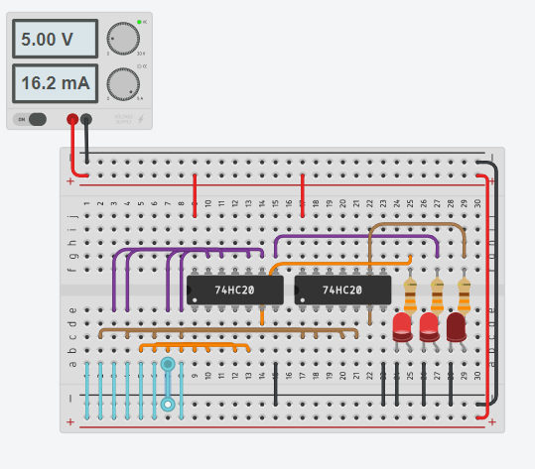
1 | 1 | 1 | 1 | 1 | 1 | 0 | 1 | 1 | 1 | 1 | 